E-Edition | Advertise | Subscribe | My Account | Newsletter SignUp

Home | News | Sports | Opinion | Politics | Things To Do | Obituaries | Classifieds | Search

Opinion: The power of kindness
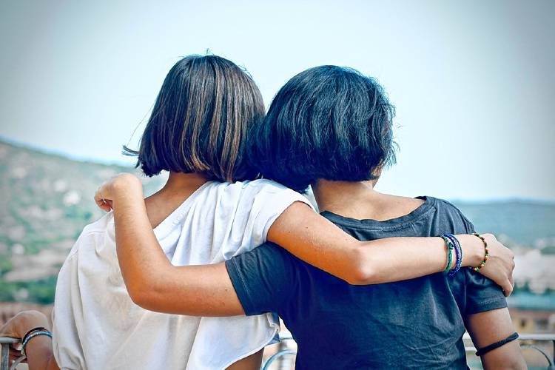
Pixabay - Pixabay
By STEPHANIE RUTT | Published: 11-30-2023 - 07:00:15
Rev. Dr. Stephanie Rutt is founding minister of the Tree of Life Interfaith Temple in Amherst. She lives in Nashua.
With so much division, manipulation, finger-pointing, and downright ugliness masquerading as civil discourse these days, it's easy to lose sight of the good. And then something happens, quite unexpectedly, that brings a ray of hope to where there was such challenge and despair. It was a simple thing really. Usually is. I'm fortunate to live in a large mill building with people of many ethnicities and it's not unusual to hear multiple languages in the hallways.
A few days ago, I was walking up the ramp to our main entrance and passed a middle-aged woman and, what looked to be, her grandmother, both Muslim. The grandmother was walking behind slowly, hunched over, and seemed to have some visual impairment. I stopped at the door and held it open. When the grandmother got up to me, she paused, stared softly, and slowly bowed her head. I bowed back. Then, being shorter than me, she reached up and suddenly hugged me saying, "As-salamu alaykum," a Muslim greeting that means, "Peace be upon you." She held on for a few seconds as I was feeling oh-my-gosh, and then was finally able to whisper back, "and As-salamu alaykum to you."
Then, they went in and disappeared into our building. But as I write this, I know that somewhere in one of our 300-plus apartments there's a dear elderly Muslim woman who offered me peace that day, and for that, I am surely blessed.
I know, like many, my heart breaks for the tragic war now consuming the Middle East. As I expressed in my November 1st My Turn , "Middle East Peace," I could respond in kind to the woman because I've spent time praying with both my Muslim and Jewish friends. I know that had the elderly woman I met at the door been Jewish, I'm sure she'd have blessed me with, "Shalom aleichem," generally translated, "Peace unto you." I could have responded in kind, "Aleichem shalom," and there would have been no difference in the gift offered or received.
Funny how such a simple act of kindness can ripple and instantly soothe a heart overcome with turbulent fear for the future. We forget how powerful kindness is, too easily discounted, worthy perhaps only of a fleeting smile before getting back to more serious business. That is until an elderly Muslim woman spontaneously hugs you or you, again unexpectedly, have an opportunity to offer something in kind.
A number of years ago, at this time of year, I was standing in line at one of the quick checkout lanes in a grocery store in Milford. It was early evening and the store was packed. The couple ahead of me had an infant who was becoming more and more fussy. Both parents looked completely frazzled and had that I-can't-remember-the-last-time-I-slept look. As mom tried to calm the infant, dad was desperately counting out his last penny. He came up short and the cashier, regretfully, said he'd have to put something back.
Without thinking, I jumped in and said, "Don't worry. I'll cover the bill." I'll never forget the surprise, almost disbelief, mixed with deep gratitude, in their eyes as they left the store. But the good news is I'm absolutely certain that many of you reading this would have done the exact same thing.
But the story doesn't end there. About a week later, I was in line again at the same store. This time, as I started to empty my cart, the woman in front of me said, "I'm paying for your groceries today. I was behind you last week and saw what you did for that couple with the baby. Now I'd like to do something for you."
Who knows? Maybe this column will find her and she'll remember that day and know that her kindness still makes me smile all these years later.
Kindness doesn't need to know what political party you belong to. It doesn't care what religion you are or how much money you make. No application is required. We offer kindness because something bigger than us, in the moment, compels us. It sparks an ember, long smothered, awakening an innate sense of our shared humanity, and ignites the fire of neighborly love even before we know what's happening.
And it changes everyone and everything in its wake. Giver. Receiver. Witness. One and the same now. For the moment, it frees all from the shackles of drudgery, oppression and hatred to find hope and joy where no one would have thought to look. And even years later, just the memory can rekindle the ember again. Such is the power of kindness.
As-salamu alaykum.

