- Home
- News
- Opinion
- Sports
- Politics
- Arts & Life
- Obituaries
- Classifieds
- Search
Opinion: The true meaning of Christmas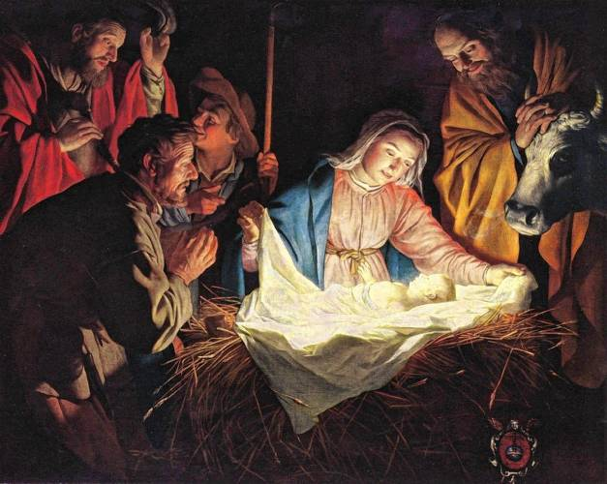
“Judging from his words, I believe today he’d be at our borders tearing down walls and welcoming all who yearned for safety and comfort. I can imagine he’d be washing their feet and making sure they were properly clothed and fed for, as we read in Matthew 25:40,” writes Rutt. Pixabay
By STEPHANIE RUTT | Published: 12-24-2023 7:00 AM

Rev. Dr. Stephanie Rutt is founding minister of the Tree of Life Interfaith Temple in Amherst. She lives in Nashua.
I’ll never know her name. Yet, she’ll live in my heart until my last breath.
It started with one of those warnings from a newscaster, “The images are disturbing.” Then, amid the overwhelming devastation, I saw a little girl, maybe three or four years old, lying on a makeshift stretcher. Over her small body, her dress lay limp, covered with blood and filth spewed from the ravages of war. But it was the blindfold tied around her matted hair that I could imagine left her feeling the most scared: viciously trapped, panicking, frantically groping for any escape out of the dark, crying out, pleading, again and again, “Mama, Mama.”
It was an image from Gaza but to ask where, whom or even why, is to have already lost the moral compass. Perhaps better a question would be, “What if it were my child? My daughter. My son.” And what if I remembered that, just a short time ago, she or he was roaming free from concern, likely being messy, clothes soiled from fun due to all kinds of imaginary shenanigans?
Pause, feel — What if it were my child?
I know many of us are grateful each night, regardless of our particular challenges and circumstances, that we, at least for now, live in a country that’s not being decimated by war. Most of us have a warm bed out of the cold. We’re spending an unprecedented amount for gifts this Christmas and will have to do some serious dieting come January due to our holiday feasting. We can’t even imagine losing water, food, sanitation, safety, with no back-on date posted on our smartphones. We can’t. Or maybe we can so we quickly offer our passing, “That’s so sad,” and escape into the holiday classic, “It’s a Wonderful Life.” I’m no different most of the time.
Until I heard, “Mama. Mama,” and something in me stirred, deep.
And as I’ve sat with it, it’s made me hold more closely the teachings of the one called Jesus, this Holy Week in particular, as we anticipate the celebration of his birth on Christmas Day. Yes, I’m an Interfaith minister but I also have a long, endearing, familial relationship with Christianity through a small country Methodist Church in the Deep South. And I sense that if Jesus were here, he’d be quite dismayed with how those who call themselves the faithful have come to practice his teachings.
It might serve us all well to remember that Jesus was not a Christian. He was a Jew. The religion of Christianity was founded generations after Jesus’ death by those who could still hear, across time, the ecstatic cry that just his simple presence could elicit. They did, however, manage to record many of his teachings which, by any standard looking at events today, should give us all pause.
For example, Jesus was one who preferred to live on the fringes of society and hang out with those people others would not. Judging from his words, I believe today he’d be at our borders tearing down walls and welcoming all who yearned for safety and comfort. I can imagine he’d be washing their feet and making sure they were properly clothed and fed for, as we read in Matthew 25:40, “I tell you whenever you did these things [fed, clothed and invited in the stranger] for one of the least of these brothers of mine, you did them for me.”
Similarly, I don’t believe in the Middle East today he’d stop to see any distinction between Jews, Muslims, Arabs, Palestinians, before serving any and all who were in need. He’d certainly not be concerned with whether or not they’d found him or loved his Holy Father through the proper religion. Today, he’d most likely look with bewilderment at those who’ve claimed him as their own such as those Christians who say God revealed to them that they should care predominately for Israeli Jews. No such hierarchy of worthiness is revealed in Jesus’ teachings, in fact, quite the opposite.
“Just as I have loved you, you must also love one another. (John 13:34)
Perhaps, as expressed in the beautiful hymn, “Oh Holy Night,” this Christmas we should all hope to experience the unconditional love Jesus taught, to better live as he did so we too could feel “a thrill of hope,” as our “weary world rejoices,” remembering “He taught us to love one another,” and that “his law is love and his gospel is peace.”
Most of all, I pray we all may have just a moment when we too find ourselves consumed by that ecstatic cry, so when we sing, “fall on your knees, O hear the Angels’ voices,” we can do nothing else.
Maybe then, we could hear, a world away, a small voice crying, “Mama, Mama,” and know the true meaning of Christmas.

