- News
- Sports
- Opinion
- Obituaries
- Politics
- Arts & Life
- More...

Opinion > Columns

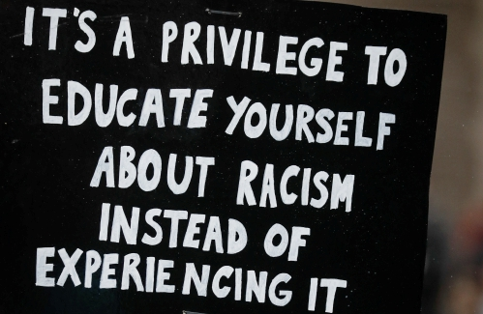

My Turn: Free to dream a life
By STEPHANIE RUTT
For the Monitor
Published: 3/5/2022 6:00:47 AM
Modified: 3/5/2022 6:00:11 AM
you have chosen the hip shirt
with the star on it
for today
and you dream
you will
choose your
life
- Thomas C. Kent, Blue Lights and River Songs
I recently came upon this book I’d had in college in 1971 and was mesmerized by this short poem. It caused me to reflect upon what dreams have been lost since that time and which ones still lay silent in broken hearts, hearts that once yearned to choose a life.
I thought about the cry of our times, “Black Lives Matter,” and the resounding echo back, “All Lives Matter,” bouncing off deaf walls. Of course, all lives matter! Yet, many disenfranchised groups have had to fight for the right to matter, for inclusion in our founding ‘all men are created equal’ ideal — African Americans, Native Americans, many other ethnic groups, women, the LGBTQ community, the disabled, the poor, the homeless, the mentally ill.
Yes, how wonderful it would be if we could all stand side by side with our disenfranchised brothers and sisters and, together, proclaim, “All Lives Matter!” However, when we witness horrific injustice, even murder, of a fellow American, as we did in the killing of George Floyd, as well as the killing of all those who came before him and of the many others since, such a cry rings flat and feels like a not–so–subtle attempt to veil the historical legacy of discrimination and racism found in these United States where the ‘all men are created equal’ ideal neglected to specify that, in essence, the ‘all men’ referred only to aristocratic white males.
Truly, I wish we didn’t even need to say the words “Black Lives Matter.” But I’ve seen too much. Felt too much. Known too much to deny my part — yes, my part. I remember “white only” drinking fountains and bathrooms and not just in the deep south. I remember shacks clustered on the back dusty roads and heard of “colored towns” hidden deep in the woods.
In the city, I could see at the edge of town those segregated neighborhoods, especially at night when the oil lamps glowed, where white folks just didn’t go, “‘cause, you know, colored people live there.” I’m old enough to remember that, of course, I must be somehow better “‘cause yous is white.”
Sheltered in my privileged status, I could easily look away, get busy, deny, rationalize, anything but recognize and acknowledge my sisters’ and brothers’ disenfranchised isolation. Like so many of my status, by not giving voice to the uncomfortable truth, I helped to perpetuate the lie.
And such complacency, however innocent or unintended, continues to allow for the seed of racism to take hold, generation after generation. This seed begins with what I’ve imagined being the moment and it happens, mercilessly, in the hearts of children. Something happens and suddenly they know they’re different and that that difference isn’t good.
Sadly, in that moment, I can imagine that even the most sparkly star on their shirt could begin to dim. For our African American brothers and sisters, I can imagine it happening one Christmas sitting on Santa’s lap. “Why does Santa look different?” Or, perhaps in church. “Why does Jesus?” Or, perhaps, it wasn’t any specific event but just, one day, a sour, sinking, “it ain't ever goin’ away” feeling that Black made them different, less than, and worst of all, it couldn’t be changed or gotten rid of.
When we deny any group of people the right to dream, to choose a life, something dies within them and, I believe, within us as well. This is actually a great blessing because this painful acknowledgment can only arise from an undeniable knowing that we’re all one family so what we do to the other we do to ourselves.
The good news is we can choose to reject the lie and follow the truth that we’re all truly equal in the eyes of our creator. This means that, perhaps, we of privilege must also give up the lie we’ve knowingly or unknowingly told ourselves: that our lives matter more than others.
Acknowledging our part in the propagation of racism and discrimination is not for the fainthearted. If we’re to avoid postures of either moral superiority on the one hand or overplayed humility on the other, we must be willing to follow the advice of Dr. Martin Luther King, Jr., and first look within ourselves. Yes, within.
We must search our own hearts, indeed conduct a fierce inventory, of where we’ve been blind but now are daring to see. Maybe then we’d be ready to approach our African American brothers and sisters and ask, “What can I do to ensure that the ‘moment’ never happens to another innocent child?” and then be willing to hear the answers.
And, if so, maybe, just maybe, we’d all come a bit closer to the day when all peoples may be free to dream a life . . . a life of their choosing.
Rev. Dr. Stephanie Rutt is founding minister of the Tree of Life Interfaith Temple in Amherst. She lives in Nashua. To read more of her writing visit becomeaforceforgood.com.

