- News
- Sports
- Opinion
- Obituaries
- Politics
- Arts & Life
- More...

Opinion > Columns
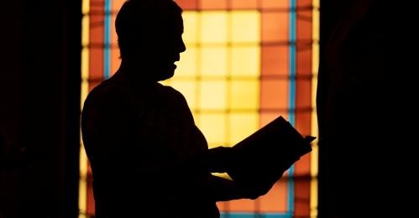

Opinion: Praying for those of different faiths to come together
By STEPHANIE RUTT
Published: 10/9/2022 7:00:30 AM
Modified: 10/9/2022 7:00:18 AM
Rev. Dr. Stephanie Rutt is founding minister of the Tree of Life Interfaith Temple in Amherst. She lives in Nashua. To read more of her writing visit becomeaforceforgood.com.
It feels like a fairy tale now and yet it wasn’t even twenty years ago. I was convener of the Souhegan Valley Interfaith Council and we, joining with the Nashua Interfaith Council, sponsored a series of discussions called “To hear how others pray.”
We invited clergy and laypeople from across faith traditions to join — Christians, Catholic and Protestant, Jews, Muslims, Buddhist, and Bahai among others to share their experience of prayer within their tradition. My hope was that we might see more clearly our common humanity, while at the same time, practice respecting our differences.
The talks were well attended and received, and unmarred by hate speech or violence. But this was, again, once upon a time.
Later, I decided to send a letter of invitation to join our Council to all the faith communities in our area not already involved. One reply was from a pastor of a Christian Evangelical church who was writing to politely decline my invitation. He described, simply, how his congregation, and others like his, had different answers to community and societal problems, leaning on biblical scripture.
He thanked me for inviting him and said he appreciated my efforts to bring people together. Cordial, respectful, and appreciative while still standing firm in his beliefs. It’s almost hard to believe now. But this was, again, once upon a time.
What has happened? It seems to me such gatherings and respect shown among those who clearly hold different beliefs can only thrive when there is a mutual understanding of the importance of the separation of church and state. Only then can my Evangelical friend and his church community feel free to meet, attract the faithful, and worship just down the street from my church community doing the same.
There’s a reason the founding fathers didn’t specify we should be a Christian theocracy. As many were fleeing religious persecution, I believe that they, imperfect individuals as they were, heralded a higher vision for this great experiment, ‘We the people.’
But in only a few years, as the separation of church and state has steadily blurred, we find this great democratic experiment on the verge of self–destructing as we careen out of control heading straight into Christian nationalism. Sadly, I know many devout Christians are watching this, with nothing short of incredulous disbelief, as one sect of their faith tradition charges forward leading this destruction to make way for the new ‘We the Christians,’ as defined by their particular religious ideology.
And we the people, where the majority has a say in creating policy, become the fallout. Already it no longer matters that the majority of Americans, secular as well as religious people, for a variety of reasons, want legal access to abortion. It doesn’t matter that most Americans, fully supportive of the right to bear arms, also understand that ordinary citizens don’t need to carry weapons of war.
It no longer matters that our Statue of Liberty used to offer the promise of welcome to all. Now, reasonable, compassionate, immigration policy is only a dream as, in particular, growing hate groups conveniently blend national, ethnic, and religious ideology, asserting neo-Nazi and white supremacist values.
As I watch the current political ads, I see Democrats focusing almost exclusively on the issue of abortion and Republicans on the economy. Both are missing the mark as I see the much larger issue being, do we uphold the great ‘We the people’ experiment or stand by and let one sect of one faith tradition lead us all into unilateral conformity with their beliefs and values?
I would challenge all of us, regardless of political or religious persuasion, who see ourselves as Americans first, who believe in ‘We the people’ first, to resist polarization and stereotyping and not be shy about standing firm in defense of our great democratic experiment. Those who are leading the charge toward a Christian theocracy are not being shy or camouflaging their goals. They’re actually using the freedoms of ‘We the people’ to their advantage.
It is we, Democrats and Republicans, Christians and those of other faith traditions who uphold and value the separation of church and state and are committed to ‘We the people,’ who must stand together, talk together, work together.
Maybe then, once upon a time can be our time again.

