- News
- Sports
- Opinion
- Obituaries
- Politics
- Arts & Life
- More...

Opinion > Columns

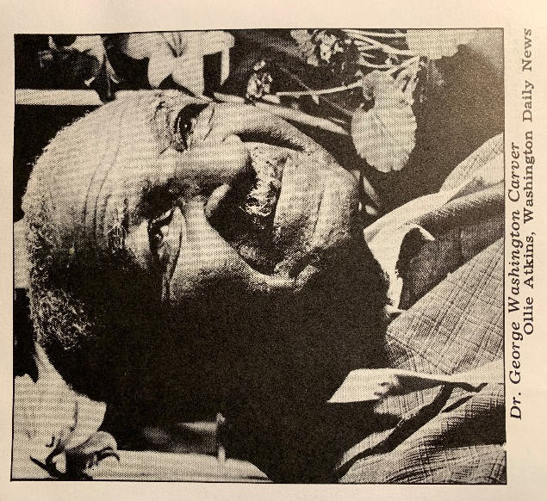

Opinion: The man who talks with the flowers
By STEPHANIE RUTT
Published: 2/7/2023 6:00:25 AM
Modified: 2/7/2023 6:00:05 AM
Rev. Dr. Stephanie Rutt is founding minister of the Tree of Life Interfaith Temple in Amherst. She lives in Nashua.
“How do I talk to a little flower? Through it I talk to the Infinite. And what is the Infinite? It is that still small voice that calls up the fairies.” – Dr. George Washington Carver
Having been an interfaith minister for almost twenty years, I have hundreds of books in my personal library on a wide variety of theological and spiritual topics. But one short, 62-page booklet, is one of my most favorites — The Man Who Talks with the Flowers: The Life Story of Dr. George Washington Carver by Glenn Clark. It’s the source for this column offered in celebration of Black History Month.
Most people know George Washington Carver as the one who discovered over three hundred uses for the peanut and over one hundred and fifty uses for the sweet potato. Some may remember him as a renowned agricultural scientist, a Black man who lived in the late 19th and early 20th centuries, who always wore a flower in the buttonhole of his jacket — the old, scruffy, black one he bought for about $2.
But few know of his deeply spiritual side and to what and to whom he credited his amazing discoveries. A clue: consider how he started each day.
“All my life I have risen regularly at four o’clock and have gone into the woods and talked with God. There he gives me my orders for the day. After my morning’s talk with God, I go into my laboratory and begin to carry out his wishes.”
And when asked, “You have a habit of talking to the little flower or peanut and making it give up its secrets. How do you do it?”
“You have to love it enough,” answered Carver. “Anything will give up its secrets if you love it enough.” And he added, “When I silently commune with people, they give up their secrets also — if you love them enough.”
Lately, I’ve been thinking a lot about this love. I don’t think it’s the more common emotional love we’re used to that can grow and wain with circumstance. No. I think the love Carver was referring to is what I would call devotional love, a love so complete unto itself that it needs nothing.
For example, when I’m able to listen to, say, another person with this kind of love, my own agenda, thoughts, and imagined replies are not playing in the background waiting to chime in. I’m able to be completely present to the one right in front of me because I’m not in the way. Simple, yes but, surely, not easy. But just imagine what might happen, how it could shift our national dialogue if more of us strived to do this with one another.
For Carver, the ability to extract information from the peanut, sweet potato, clays of the hills, the flower or just to create a heart space within which another person could land, was directly related to those early morning talks with God. He didn’t need to spend his time searching for approval, agreement or validation from others because he already knew himself to be a child of God and knew his Creator would guide him to serve the greatest good.
He’s best known for being able to talk with the flowers as he felt they were windows through which he could see the face of God. Toward the end of his life, he shared an important message he’d received from a little flower.
“It told me there is going to be a great spiritual awakening in the world, and it’s going to come from people connected with you and me, from plain, simple people who know, not merely believe, but actually know God answers prayer. It’s going to arise from men who are going about their work and putting God into what they do, from men who believe in prayer, and want to make God real to mankind.”
While Carver was a Christian, I don’t believe it matters what faith tradition you practice as all religions can agree that God is love. But the life of George Washington Carver gives us a glimpse into just what that love might look like in real life, emanating from the peanut, sweet potato, clays of the hills, flowers, and, most blessedly, from the hearts of our fellow brothers and sisters.
Can we too imagine loving enough to see all creation as that window through which our Creator speaks? Can we too love enough to join hands across faith traditions, with all God’s children, to create that great spiritual awakening? It just may be, in the end, what’s needed to save us, our world, from escalating chaos and destruction.
But, like George Washington Carver, I have hope that it’s possible. Why? The flower said so.

